CH13 Building Information Systems

學習目標:

* 1. 建立新系統如何產生組織變革？
  2. 系統開發過程中的核心活動是什麼？
  3. 系統建模和設計的主要方法是什麼？
  4. 建立資訊系統的替代方法是什麼？
  5. 在數位公司時代，有什麼新的系統建構方法？
* Angostura Builds a Mobile Sales System

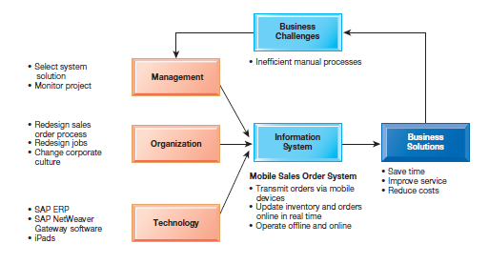

* How did Angostura’s Mobile Sales App meet its information requirements? How effective a solution was Angostura’s Mobile Sales App? Why? How much did the new system change the way Angostura ran its business?

1. How does building new systems produce organizational change?
   * Systems Development and Organizational Change

* Automation
* Increases efficiency
* Increases efficiency
* Rationalization
* Streamlines standard operating procedures
* Often found in programs for making continuous quality improvements
  + Total quality management (TQM)
  + Six sigma
* business process redesign
* Analyze, simplify, and redesign business processes
* Reorganize workflow, combine steps, eliminate repetition
* paradigm shifts
* Rethink nature of business
* Define new business model
* Change nature of organization

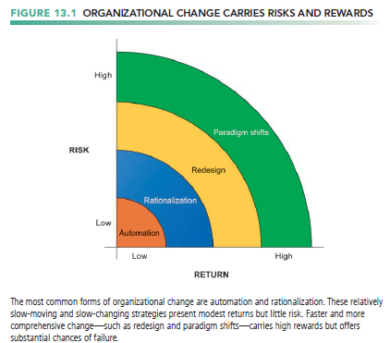

* + Business Process Redesign
* Preface
* Business process management (BPM)
  + Variety of tools, methodologies to analyze, design, optimize processes
  + Used by firms to manage business process redesign
* Companies practicing business process management go through the following steps
  + 1. Identify processes for change
  + understanding what business processes need improvement.
    1. Analyze existing processes
  + Existing business processes should be modeled and documented, noting inputs, outputs, resources, and the sequence of activities.

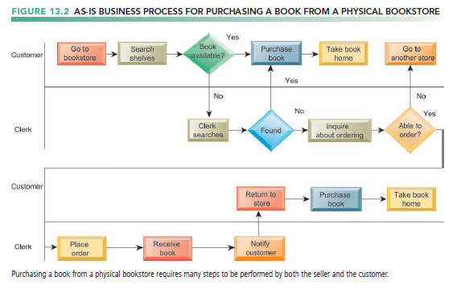

* + 1. Design the new process
  + Once the existing process is mapped and measured in terms of time and cost, the process design team will try to improve the process by designing a new one.
  + will be documented and modeled for comparison with the old process

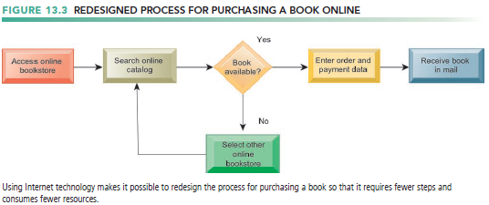

* + 1. Implement the new process
  + Once the new process has been thoroughly modeled and analyzed, it must be translated into a new set of procedures and work rules.
  + Employees working with the process may recommend improvements
    1. Continuous measurement
  + Once a process has been implemented and optimized, it needs to be continually measured.
* Tools for Business Process Management
* Identify and document existing processes.
  + document and monitor business processes to help firms identify inefficiencies.
* Create models of improved processes.
* Capture and enforce business rules for performing, automating processes.
* Integrate existing systems to support process improvements.
* Verify that new processes have improved.
* Measure impact of process changes on key business performance indicators.
* automate some parts of a business process and enforce business rules

1. What are the core activities in the systems development process?
   * Preface

* New information systems are an outgrowth of a process of organizational problem solving.
* systems development
* The activities that go into producing an information system solution to an organizational problem or opportunity

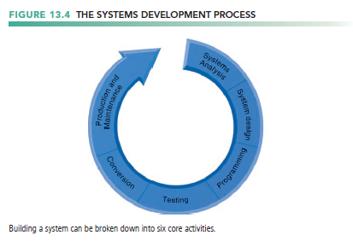

* + Systems analysis
  + Systems design
  + Programming
  + Testing
  + Conversion
  + Production and maintenance
  + Systems Analysis
* Preface
* Systems analysis
  + the analysis of a problem that a firm tries to solve with an information system
  + It consists of defining the problem, identifying its causes, specifying the solution, and identifying the information requirements that must be met by a system solution.
* Includes feasibility study
  + determine whether that solution is feasible, or achievable, from a financial, technical, and organizational standpoint.
  + Is solution feasible and good investment?
  + Is required technology, skill available?
* Establishing Information Requirements
* Who needs what information, where, when, and how
* Define objectives of new/modified system
* develops a detailed description of the functions that the new system must perform
* Detail the functions new system must perform
* Faulty requirements analysis is a leading cause of systems failure and high systems development costs
  + Systems Design
* Preface
* systems design shows how the system will fulfill analysis objective.
* Describes system specifications that will deliver functions identified during systems analysis
* the overall plan or model for that system.
* These specifications should
* address all of the managerial, organizational, and technological components of the system solution

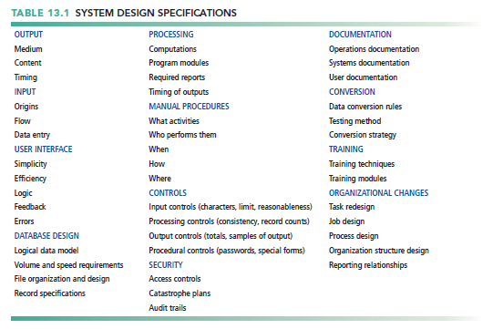

* The Role of End Users
* User information requirements drive system building
* Users must have sufficient control over the design process
  + ensure that the system reflects their business priorities and information needs, not the biases of the technical staff.
* Working on design increases users’ understanding and acceptance of the system.
  + Completing the Systems Development Process
* Programming
* System specifications from design stage are translated into software program code
* purchase the software that meets the requirements for a new system from external sources
* Testing
* Exhaustive and thorough testing must be conducted to ascertain whether the system produces the right results.
* Unit testing (program testing)
  + consists of testing each program separately in the system.
* System testing
  + Test functioning of system as a whole
* Acceptance testing
  + Makes sure system is ready to be used in production setting
* Test plan
  + All preparations for series of tests

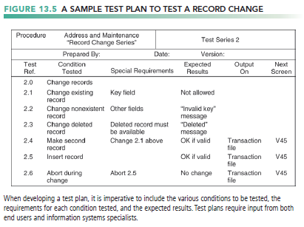

* Conversion
* the process of changing from the old system to the new system.
* Requires end-user training
* Finalization of detailed documentation showing how system works from technical and end-user standpoint
* the parallel strategy
  + both the old system and its potential replacement are run together for a time until everyone is assured that the new one functions correctly
* the direct cutover strategy
  + replaces the old system entirely with the new system on an appointed day.
* the pilot study strategy
  + introduces the new system to only a limited area of the organization
* the phased approach strategy
  + introduces the new system in stages, either by functions or by organizational units.
* Production and Maintenance
* System reviewed to determine if revisions needed
* May include post-implementation audit document
* Maintenance
  + Changes in hardware, software, documentation, or procedures to a production system to correct errors, meet new requirements, or improve processing efficiency
  + 20 percent debugging, emergency work
  + 20 percent changes to hardware, software, data, reporting
  + 60 percent of work: user enhancements, improving documentation, recoding for greater processing efficiency

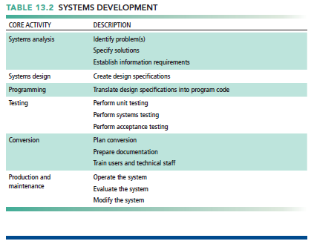

1. What are the principal methodologies for modeling and designing systems?
   * Preface

* Most prominent methodologies for modeling and designing systems
* Structured methodologies
* Object-oriented development
  + Structured Methodologies
* Structured
* Techniques are step-by-step, progressive
* process-oriented
* focusing primarily on modeling the processes, or actions that capture, store, manipulate, and distribute data as the data flow through a system.
* separate data from processes.
* A separate programming procedure must be written every time someone wants to take an action on a particular piece of data.
* Data flow diagram (DFD)
* Primary tool for representing system’s component processes and flow of data between them
* offers a logical graphic model of information flow
* partitioning a system into modules that show manageable levels of detail
* specifies the processes or transformations that occur within each module and the interfaces that exist between them.
* depict higher-level processes as well as lower level details.

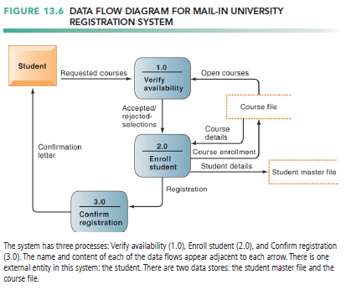

* Data dictionary
* Defines contents of data flows and data stores
* Process specifications
* Describe transformation occurring within lowest level of data flow diagrams
* Structure chart
* Top-down chart, showing each level of design, relationship to other levels, and place in overall design structure

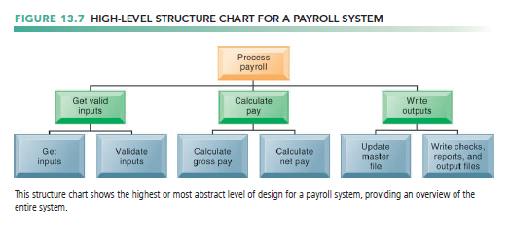

* + Object-Oriented Development
* Object is basic unit of systems analysis and design
* Object
  + combines data and the specific processes
  + Data encapsulated in object can be accessed and modified only by operations, or methods, associated with that object
* The system is modeled as a collection of objects and the relationships among them.
* Object-oriented modeling based on concepts of class and inheritance
  + May inherit structures and behaviors of a more general, ancestor class

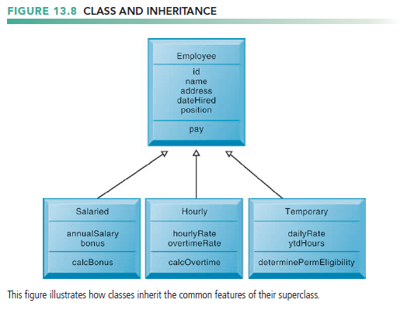

* more iterative and incremental than traditional structured development.
  + Systems analysis : Interactions between system and users analyzed to identify objects
  + Design phase: Describes how objects will behave and interact; grouped into classes, subclasses, and hierarchies
  + Implementation: Some classes may be reused from existing library of classes, others created or inherited
* Because objects reusable, object-oriented development can potentially reduce time and cost of development
  + Computer-Aided Software Engineering
* Software tools to automate development and reduce repetitive work, including
* Graphics facilities for producing charts and diagrams
* Screen and report generators, reporting facilities
* Analysis and checking tools
* Data dictionaries
* Code and documentation generators
* Support iterative design by automating revisions and changes and providing prototyping facilities
* Require organizational discipline to be used effectively

1. What are alternative methods for building information systems?
   * Traditional Systems Life Cycle

* the oldest method for building information systems.
* phased approach
* Development divided into formal stages
* “Waterfall” approach: One stage finishes before next stage begins
  + one stage are completed before work for the next stage begins
  + Activities can be repeated, but volumes of new documents must be generated and steps retraced if requirements and specifications need to be revised.

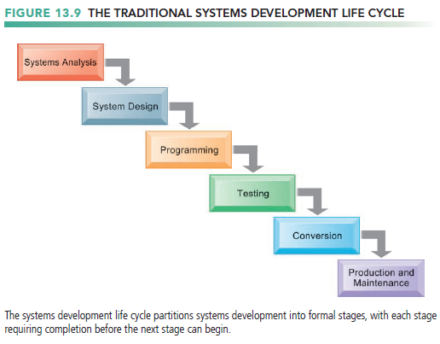

* maintains a formal division of labor between end users and information systems specialists.
* emphasizes formal specifications and paperwork
* Still used for building large complex systems
* can be costly, time-consuming, and inflexible.
* not suitable for many small desktop systems
  + Prototyping
* Preface
* building an experimental system rapidly and inexpensively for end users to evaluate.
* Prototype: Working but preliminary version of information system
  + Approved prototype serves as template for final system
* iterative process of systems development
  + The process of building a preliminary design, trying it out, refining it, and trying again
* more explicitly terative than the conventional life cycle
* Steps in Prototyping
* Identify user requirements.
* Develop initial prototype.
* Use prototype.
* Revise and enhance prototype.

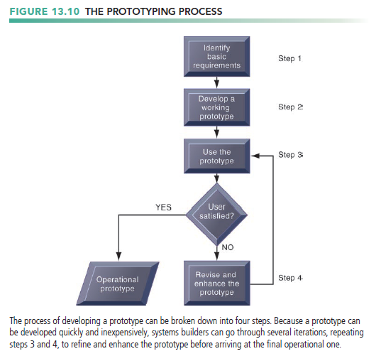

* Advantages and Disadvantages of Prototyping
* Advantages
  + Useful if some uncertainty in requirements or design solutions
  + Often used for end-user interface design
  + More likely to fulfill end-user requirements
* Disadvantages
  + May gloss over essential steps
  + May not accommodate large quantities of data or large number of users
  + May not undergo full testing or documentation
  + End-User Development
* Allows end users to develop simple information systems with little or no help from technical specialists
* Reduces time and steps required to produce finished application
* Tools include
* User friendly query languages and reporting
  + A query language is a software tool that provides immediate online answers to questions that are not predefined
* PC software tools
* Advantages
* More rapid completion of projects
* High level of user involvement and satisfaction
* Disadvantages
* cannot replace conventional tools for some business applications
  + cannot easily handle the processing of large numbers of transactions or applications with extensive procedural logic and updating requirements
* Inadequate management and control, testing, documentation
* Loss of control over data
* Managing end-user development
* Require cost-justification of end-user system projects
* Establish hardware, software, and quality standards
  + Application Software Packages, Software Services, and Outsourcing
* Application Software Packages and Cloud Software Services
* Save time and money
* many systems are based on commercially available application software packages or cloud software as a service (SaaS)
* Many offer customization features
  + Software can be modified to meet unique requirements without destroying integrity of package software
* Package and SaaS vendors supply much of the ongoing maintenance and support for the system
* Evaluation criteria for systems analysis include
  + Functions provided by the package, flexibility, user friendliness, hardware and software resources, database requirements, installation and maintenance efforts, documentation, vendor quality, and cost
* Request for Proposal (RFP)
  + Detailed list of questions submitted to packaged-software vendors
  + Used to evaluate alternative software packages
* Outsourcing
* Cloud and SaaS providers
  + Subscribing companies use software and computer hardware provided by vendors
* External vendors
  + Hired to design, create software, but that company would operate the system on its own computers.
  + Domestic outsourcing : Driven by firms need for additional skills, resources, assets
  + Offshore outsourcing : Driven by cost-savings
* Advantages
  + Allows organization flexibility in IT needs
* Disadvantages
  + Hidden costs, for example:
  + Identifying and selecting vendor
  + Transitioning to vendor
  + Opening up proprietary business processes to third party

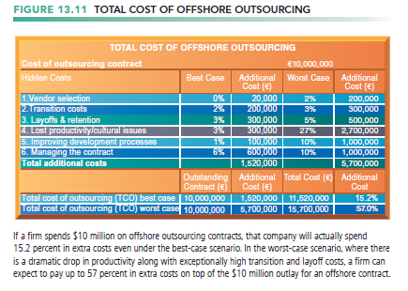

1. What are new approaches for system building in the digital firm era?
   * Rapid Application Development (RAD), Agile Development, and DevOps

* Rapid Application Development (RAD)
* Process of creating workable systems in a very short period of time with some flexibility to adapt as a project evolves.
* involves close teamwork among end users and information systems specialists as well as among the IT groups developing and operating the systems
* often can be assembled from prebuilt components
* does not have to be sequential
* key parts of development can occur simultaneously.
* Visual programming and other tools for building graphical user interfaces
* Iterative prototyping of key system elements
* Automation of program code generation
* Joint application design (JAD)
* accelerate the generation of information requirements and to develop the initial systems design.
* brings end users and information systems specialists together in an interactive session to discuss the system’s design.
* Can significantly speed up design phase and involve users at intense level
* Agile development
* focuses on rapid delivery of working software by breaking a large project into a series of small subprojects
  + Treated as separate, complete projects
  + completed in short periods of time using iteration and continuous feedback.
* Emphasizes face-to-face communication over written documents, allowing collaboration and faster decision making
* DevOps
* builds on agile development principles
* stands for “development and operations” and emphasizes close collaboration between the software developers and the IT operational staff
* tries to change this relationship by promoting better and more frequent communication and collaboration between systems development and operations groups
* change along with agile techniques, standardized processes, and more powerful automated software creation and testing tools
  + Component-Based Development and Web Services
* Preface
* Groups of objects that provide software for common functions (e.g., online ordering) and can be combined to create large-scale business applications
* Increasingly, these software components are coming from cloud services
* Web Services and Service-Oriented Computing
* Reusable software components that use XML and open Internet standards (platform independent)
* Enable applications to communicate with no custom programming required to share data and services
* Can engage other Web services for more complex transactions
* Using platform and device-independent standards can result in significant cost-savings and opportunities for collaboration with other companies
  + Mobile Application Development: Designing for A Multiscreen World
* mobile website
* a version of a regular website that is scaled down in content and navigation for easy access and search on a small mobile screen
* mobile web app
* an Internet-enabled app with specific functionality for mobile devices.
* native app
* a standalone application designed to run on a specific platform and device
* installed directly on a mobile device
* an connect to the Internet to download and upload data, and they can also operate on these data even when not connected to the Internet.
* Special requirements for mobile platform
* Smaller screens, keyboards
* Multitouch gestures
* Saving resources (memory, processing)
* Responsive Web design
* Web sites programmed so that layouts change automatically according to user’s computing device